FREESTORE FOODBANK
CSFP (Senior Box) Operations Manual
Partner Information
Sample - Letter of Acceptance
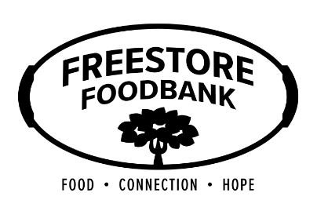
Sample Letter

[Date and Time]

[Participant Name]:

This letter confirms that you have been approved to participate in the Commodity Supplemental Food Program (CSFP).

You will be able to receive entitlements through [Agency Name], located at [Agency Address]. You will be able to receive your entitlements through [Distribution Model].

Distributions will occur [Distribution Schedule – Dates, Times, Deliveries, etc.]

If you are unable to receive your entitlements, you are able to assign a proxy that may pick up your box for you. If you have not yet authorized a proxy to pick up your box and would like to, please contact [CSFP Coordinator at Agency and Contact information] to complete the process of establishing a proxy.

Failure to receive product for [Agency Policy] may result in loss of entitlements. If you have any questions, please contact [Agency] and the information listed below.

Sincerely,

[CSFP Coordinator]
[Agency]
[Contact Information]
[Date and Time]

