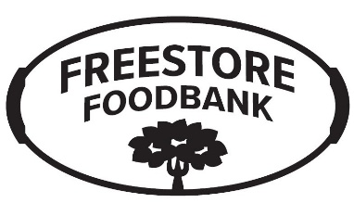 | FREESTORE FOODBANK  Partnerships and Programs
 | Pop Up Events
 | Scheduling Form

Please return this form to the Freestore Foodbank at least 2 weeks in advance of distribution date
Call 513-482-7095 if you have questions.
Return completed form by email to help@freestorefoodbank.org

Contact Information

Agency Name |  |  |  |  | Account Number:
Address:
City / State / ZIP / County:
Contact Name: |  |  |  |  | Phone Number:
Email Address:

Pop-Up Information

Date of Pop-Up: |  |  |  |  |  |  |  | Day of Week:
Frequency: |  | Weekly |  |  |  | Monthly
 |  | Bi-Weekly |  |  |  | One-Time Event
Pop-Up Start Time:
Pop-Ups are typically recommended to last 2 hours

Families Served: |  | 200 Families |  |  | 150 Families |  |  | 100 Families |  |  | Other:

Pop-Up Location Name:
Address:
City / State / ZIP / County:
Directions to Location from Cincinnati

Requestor Information

Name of Person Completing Form:
Date:

